RESOLUTION NO 004-2015

A RESOLUTION AUTHORIZING AND DIRECTING THE VILLAGE ADMINISTRATOR, OR HIS DESIGNEE, TO WORK WITH OPTIONS UTILITY CONSULTING AND DECLARING AN EMERGENCY

WHEREAS, the Village of Glenford wants to investigate options to purchase retail energy/electric services in order to realize a reduced electric supply charge per kWh; and

WHEREAS, Options Utility Consulting is an independent energy brokerage and consulting firm, located in Holland, Ohio, offering impartial advice on how to reduce and manage energy costs. Options Utility Consulting has access to all suppliers and promises to search for the most competitive electric rates for the Village; and

WHEREAS, Council for the Village of Glenford now wants to authorize the Village to work exclusively with Options Utility Consulting to help find it the best electric service rates and agreement. This is not an electric aggregation for Village residents, but rather for the Village of Glenford’s electric service.

NOW, THEREFORE, BE IT RESOLVED by the Council of the Village of Glenford, County of Perry, State of Ohio:

Section 1: Council for the Village of Glenford hereby authorizes and directs the Village Administrator, or his designee, to work exclusively with Options Utility consulting of Holland Ohio to find the best electric utility rates and secure an electric service agreement for the Village. The Village Administrator is hereby authorized and directed to execute all documents necessary to enter into this working relationship with Options Utility Consulting.

SECTION 2: All prior legislation, or any parts thereof, which is/are inconsistent with this Resolution is/are hereby repealed as to the inconsistent parts thereof.

SECTION 3: It is hereby found and determined that all formal actions of this Council concerning and relating to the adoption of this Resolution were adopted in an open meeting of this Council, and that any and all deliberations of this Council and any of its committees that resulted in such formal action were in meetings open to the public, in compliance with all legal requirements of the laws of the State of Ohio.

SECTION 4: Council declares this to be an emergency measure immediately necessary for the preservation of the public peace, health, and safety of this municipality and the further reason that the Village begins working immediately with Option Utility Consulting in order to take advantage of low electric rates, which are subject to change daily. Wherefore, provided this Resolution receives the required affirmative votes of Council, this Resolution shall take effect and be in force immediately upon passage by Council.

Passed in Council this _______ day of __________ 2015

____________________________

Leonard Sheppard, Mayor

ATTEST:

Linda Nicodemus, Fiscal Officer

APPROVED:

Approved as to form this 6th day of October 2015.
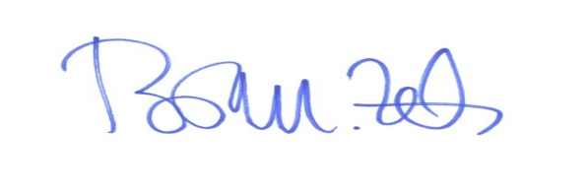
_________________________
Brian M. Zets, Esq.
Village Solicitor

