ORDINANCE NO 15-001

AN ORDINANCE CREATING, ESTABLISHING, AND ADOPTING SANITARY SEWER SYSTEM REGULATIONS FOR THE VILLAGE OF GLENFORD AND DECLARING AND EMERGENCY

WHEREAS, the Village of Glenford is in the process of constructing a complete sanitary sewer treatment facility that will consist of a traditional gravity collection system of 8” gravity mains and standard manholes to a centralized treatment plant; and

WHEREAS, in order to protect and preserve the physical integrity of the sanitary sewer system collection and treatment systems, Council for the Village of Glenford now needs to create, establish, and adopt sewer system regulations. These Regulations will provide guidelines, policies, rates, and penalties for the safe, efficient, and sound fiscal operation of the sanitary sewer collection and treatment system

NOW, THEREFORE, BE IT ORDAINED by the Council of the Village of Glenford, County of Perry, State of Ohio:

Section 1: Council for the Village of Glenford hereby creates, establishes, and adopts the Sanitary Sewer System Regulations attached hereto as Exhibit A and incorporated herein by reference.
SECTION 2: All prior legislation, or any parts thereof, which is/are inconsistent with this Ordinance is/are hereby repealed as to the inconsistent parts thereof.

SECTION 3: It is hereby found and determined that all formal actions of this Council concerning and relating to the adoption of this Ordinance were adopted in an open meeting of this Council, and that any and all deliberations of this Council and any of its committees that resulted in such formal action were in meetings open to the public, in compliance with all legal requirements of the laws of the State of Ohio.

SECTION 4: Council declares this to be an emergency measure immediately necessary for the preservation of the public peace, health, and safety of this municipality and the further reason that the Village must create and adopt these regulations immediately, as required by the Ohio EPA and Perry County Health Department. Wherefore, provided this Ordinance receives the required affirmative votes of Council, this Ordinance shall take effect and be in force immediately upon passage by Council.

Passed in Council this _______ day of __________ 2015.

____________________________

Leonard Sheppard, Mayor

ATTEST:

Linda Nicodemus, Fiscal Officer

APPROVED:

Approved as to form this 2nd day of February 2015
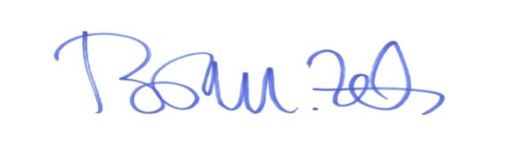
_________________________
Brian M. Zets, Esq.
Village Solicitor

