ORDINANCE: 15-004

AN ORDINANCE FINDING PERSONAL PROPERTY IS NOT NEEDED FOR MUNICIPAL PURPOSE AND AUTHORIZING/DIRECTING THE VILLAGE ADMINISTRATOR, OR HIS DESIGNEE, TO ADVERTISE BIDS TO SELL THE PROPERTY AND DECLARING AN EMERGENCY

WHEREAS, the Village of Glenford currently owns a Bush Hog, Model M2254, Series 12-00240; and

WHEREAS, the Board, Officer, or Director having supervision or management of this equipment/ vehicle approves of selling this personal property because it is no longer need for municipal purposes; and

WHEREAS, R.C. 721.15 requires the sale of personal property not need for municipal purposes, with an estimated value of more than one thousand dollars, be authorized by ordinance and made in writing by the highest and best bid. The Village of Glenford believes the value of the Bush Hog (Model M2254) is more than one thousand dollars. Therefore, advertisement of bids is necessary.

NOW, THEREFORE, BE IT ORDAINED, by the Council of the Village of Glenford, County of Perry, State of Ohio that:

SECTION 1: Council for the Village of Glenford has determined the following equipment/vehicle has an estimated value of more than one thousand dollars and is no longer needed for municipal purposes:

- Bush Hog, Model M2254, Series 12-00240

SECTION 2: The Village Administrator, or his designee, is hereby instructed and authorized to advertise, not less than two (2) nor more than four (4) consecutive weeks in a newspaper of general circulation within the municipal corporation, or as provided in R.C. 7.16, the sale of the personal property listed and identified in Section 1.

SECTION 3: It is hereby found and determined that all formal actions of this Council concerning and relating to the passage of this Ordinance were adopted in an open meeting of Council and that all deliberations of the Council and any of the decision making bodies of the Village of Glenford which resulted in such formal actions were in meetings open to the public in compliance with all legal requirements of the State of Ohio.

SECTION 4: All prior legislation, or any parts thereof, which is/are inconsistent with this Ordinance is/are hereby repealed as to the inconsistent parts thereof.

SECTION 5: Council declares this to be an emergency measure immediately necessary for the preservation of the public peace, health, and safety of this municipality and the further reason that the Village wants to sell the Bush Hog M2254 as soon as possible. Wherefore, provided this Resolution receives the required affirmative votes of Council, this Resolution shall take effect and be in force immediately upon passage by Council

Passed in Council this _______ day of __________ 2015

____________________________

Leonard Sheppard, Mayor

ATTEST:

Linda Nicodemus, Fiscal Officer

APPROVED:

Approved as to form this 13th day of April 2015.
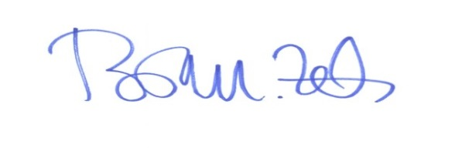
_________________________
Brian M. Zets, Esq.
Village Solicitor

