RESOLUTION: 008-2014
ADOPTED: _________________

A RESOLUTION RATIFYING THE CFLP SOLID WASTE DISTRICT’S UPDATED SOLID WASTE MANAGEMENT PLAN AND DECLARING AN EMERGENCY

WHEREAS, the Policy Committee of the Coshocton Fairfield Licking Perry Solid Waste District approved the District’s updated solid waste management plan based upon its extensive review of the existing plan and comments received at public hearing; and

WHEREAS, public hearings were held in Coshocton, Fairfield, Licking, and Perry Counties in order to provide public input and involvement. The Policy Committee considered all this input; and

WHEREAS, in order to update the Plan, the changes must be ratified by sixty percent of the townships and municipalities representing the District; and

WHEREAS, Council for the Village of Glenford believes it is in the Village’s best interest for the District to update its plan and now wants to ratify the CFLP Solid Waste District’s Updated Solid Waste Management Plan.

NOW, THEREFORE, BE IT RESOLVED by the Council of the Village of Glenford, County of Perry, State of Ohio:

Section 1: Council for the Village of Glenford hereby ratifies the CFLP Solid Waste District’s Updated Solid Waste Management Plan, and authorizes the District to submit the updated plan to the Ohio EPA for approval.

Section 2: Council for the Village of Glenford hereby authorized and directed the Fiscal Officer to mail, or otherwise deliver promptly, a certified copy of this Resolution to the Policy Committee of the Coshocton Fairfield Licking Perry Solid Waste District

SECTION 3: All prior legislation, or any parts thereof, which is/are inconsistent with this Resolution is/are hereby repealed as to the inconsistent parts thereof.

SECTION 4: It is hereby found and determined that all formal actions of this Council concerning and relating to the adoption of this Resolution were adopted in an open meeting of this Council, and that any and all deliberations of this Council and any of its committees that resulted in such formal action were in meetings open to the public, in compliance with all legal requirements of the laws of the State of Ohio.

SECTION 5: Council declares this to be an emergency measure immediately necessary for the preservation of the public peace, health, and safety of this municipality and the further reason that the Village must return a certified copy of this Resolution to the Policy Committee of the Coshocton Fairfield Licking Perry Solid Waste District no later than December 29, 2014. Wherefore, provided this Resolution receives the required affirmative votes of Council, this Resolution shall take effect and be in force immediately upon passage by Council.

Passed in Council this _______ day of ________________ 2014.

____________________________

Leonard Sheppard, Mayor

ATTEST:

Linda Nicodemus, Fiscal Officer

APPROVED:

Approved as to form this 15th day of October 2014.
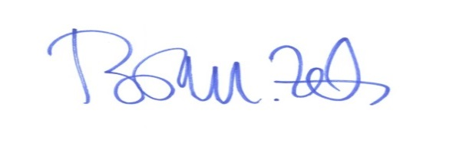
_________________________
Brian M. Zets, Esq.
Village Solicitor

